What to make of near- death experiences?
By Rev. James Coleman
A recent edition of Newsweek magazine reported on a book written by Harvard Doctor Eben Alexander called Proof of Heaven. The book is about a near death out of body experience that he had when suffering from a rare form of bacterial meningitis.
Alexander’s book and the “positive” article in Newsweek elicited a strongly worded response from Colin Blakemore, a professor of neuroscience and philosophy at the University of London.
Blakemore’s article was published by the Dominion Post on 15 October 2012. His article starts with a mocking description of what Alexander experienced and then proceeds to offer a materialistic explanation of the phenomena. His explanation of all near death experiences is that they are nothing but dreams generated by brain cells starved of oxygen.
Is that right, and why the anger? The mind- body problem is an intractable conundrum of philosophy and science. At the one end to the spectrum you have Descartes with Cartesian dualism, and the idea that the mind is an unextended separate thing or substance. At the other end you have the materialists. The assumption of materialism is that the only thing that is real is matter. Under a materialistic theory of the mind, self-awareness or what we might call consciousness, is merely a perception that we experience from the working of the brain as a machine. The experience of mind and an interior life is just a subjective impression or a by-product of the chemical processes in the brain.
There are problems with a materialist world view. One criticism was proposed by C S Lewis. He observed that if we are just here by chance, as posited by materialist evolutionary theory, and if our sense of consciousness is just a perception generated by the “brain machine” working, then how can we know what is true? How do we know that the ratio expressed as π for example is objectively true or not? Under materialism we cannot be sure.
Science fiction film makers have produced movies which carry the logic of materialism to its nth degree. They postulate computers with self-awareness, caused by the programmed operation of the digital computer. Futurists envisage the destruction of the human race by these robots due to their superior intelligence.
There are other problems with materialism too, like what actually counts as matter, particularly given modern cosmology’s suggestion that only about 5% of the universe consists of the material we would ordinarily define as matter.
But what is at the heart of the debate is how one accounts for and responds to the data.
Here the data consists of persistent stories of out of body near death experiences. There are lots of them. There is Alexander’s book and Dr Jeffery Long’s book, Evidence of the Afterlife: The science of Near Death Experiences. I remember reading a book in the 1970s which collected together many of peoples’ accounts of such experiences. Not all near- death experiences are pleasant as Blakemore claims. The New Zealand journalist Rob Harley produced a TV series called Journeys several years ago and in the opening episode there was a man speaking of his near death experience. He described it as an awful “hell- like” experience. Neither do all such experiences occur at times surrounding death. For example, similar sorts of phenomena are recorded by Oxford University’s, Religious Experience Research Unit. It records experiences from circumstances other than those associated with nearly dying. Even a casual acquaintance with Christian biographies over the last 2,000 years will reveal a rich and continual witness to such occurrences.
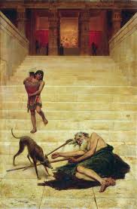
Jesus comments on the options we have for reacting to peoples’ reports of such experiences in his story about the rich man and Lazarus. There Jesus tells of two men: a rich man and poor sick beggar called Lazarus, whose sores were licked by dogs. Both men died. Lazarus went to heaven. The rich man went to hell.
In hell the rich man’s “prejudices” are removed. He asks if he can tell his 5 brothers about what he is experiencing. The answer is that if the 5 brothers will not listen to Moses and the Prophets “they will not be convinced even if someone rises from the dead.” The Christian witness is that Jesus did as a matter of literal historical fact rise from the dead. But that has not convinced everyone.
Accepting or rejecting the accounts of people who have had near death experiences is not the entry criteria for heaven or the definition of a Christian. That is solely determined by our acceptance or reject of Jesus’ claim to be God. Nonetheless one can get legitimately exasperated with dogmatic rejection of these sorts of events because they cannot be explained in purely materialist terms.
At the end of the day we will all be able to take part in our own after- death experiment. We will either simply cease to exist and hence will be unable to report back on the experience or we will be able to compare notes in either heaven or hell.

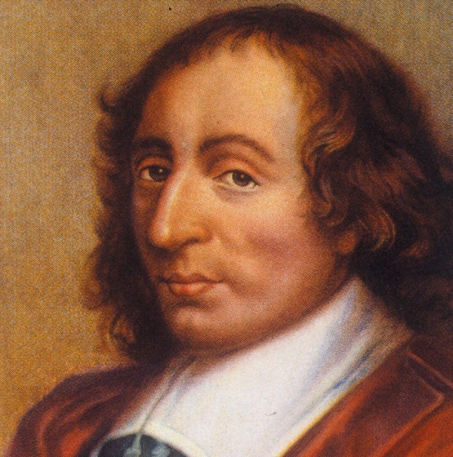
Mathematician, philosopher and Christian thinker Blaise Pascal said in his famous book Pensees that if you were to make a wager you would be mad not to bet on Jesus. After all if one is wrong it does not matter, but if the afterlife does exist, it matters very much whether you one took out spiritual insurance so to speak.

See The Oxford Companion to the Mind (Oxford University Press, 1987): Mind and Body, Mind Brain, Mind Body Problem.
It would be a mistake to assume that Descarts’s view the same as equal with Christianity’s view. It just represents one end of the spectrum.
Harper Collins Publishing, New York, 2011.
Written up by Alister Hardy, in The Spiritual Nature of Man: A Study of Contemporary Religious Experience as quoted by William A. Barry, Prayer as Personal Relationship Paulist Press, New York, 1987.
Luke 16: 19 to 31.
Luke 16: v 31.
He lived from 1623 to 1662. All images from Google images.

