Creation and evolution are they actually in conflict?
By R. James Coleman
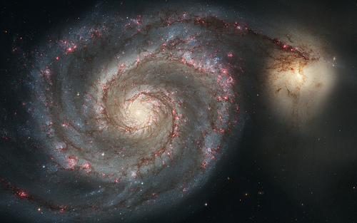
In the Dominion Post for Monday 1st October 2012 there is an article about palaeontologists having discovered feathers on dinosaurs. Rather than celebrate another breakthrough in scientific observation the article is all about saying that evolutionists are right and creationists are wrong. It is a bit like Michael Cullen’s famous post- election remark “we won you lost. Eat that!” The idea that the article gleefully advances is that evolutionary theory has won and there is no scope for creation in the mind of the thinking person.
But is that true? Is there really a winner and a loser? Is the theory of Evolution and the idea of Creation really in such conflict? The answer is that they are not in conflict at all. It is entirely possible, reasonable and rational to belief in Creation and the theory of evolution and I set out below some of the reasons why.
There is no disagreement with the observable phenomena of variation in species. For millennia farmers have observed that by selectively breeding for desirable qualities they can produce herds that by and large exhibit those desired qualities. This can be seen in the different breeds of sheep and cattle and plant varieties. The concept of selective breeding has particularly ancient roots. See the account of Jacob and his flocks in Genesis.
Both people and the environment can put this genetic pressure on a population to accentuate particular features. Environmental examples are the varying beak lengths of the birds on the Galapagos Islands, which featured so prominently in Charles Darwin’s thinking.
What Christians mean by creation is far more fundamental than variation of species and selective breading. They are concerned about the origins of the Universe, the question of why is there anything here at all rather than nothing and how life started once the Universe was created?
Modern cosmology demonstrates that the entire universe started from a single point. This is commonly called the big bang theory. The big bang theory of the beginning of the universe correlates closely to the Biblical claim of creation ex nillio – creation of the universe out of nothing.
Within the universe, we can observe particular physical laws in operation and we can quantify them by formulae. Various writers have made the point that these formulae describe the constraints of time, space, gravity, matter and energy which exist within the universe. There are 20 constraints that can be described by formulae.
It is not important for present purposes to understand exactly what the formulae are describing but rather that for each variable in each formulae there is a virtually unlimited number of possible values that could appear in them. Robert Spitzer in his book New Proofs for the existence of God observes that the important thing to understand it that the smallest changes in any of the variables would prevent their being any possibility of any life in the universe arising at all. The universe would have evolved into a black hole or a type of star called a red dwarf, and it would not have been possible for any life let alone evolution of life to have started in the universe at all.
Spitzer notes that physicists have worked out the exact probability or chance of all the variables being exactly what they actually are in the universe. The chance is $10{}^{10{}^{123}}$. That is a staggeringly small possibility. If the number produced was written out in ordinary notation the zeros required would fill a large part of the universe.
Spitzer says that in the absence of any compelling naturalistic explanation for the existence of the universe which has exactly the constraints that it does have, many physicists and philosophers consider this universe itself as evidence of the existence of a supernatural intelligence. It is that supernatural intelligence, which theologians call God.
The point of going through this is that even before we get to the question of organic life there are compelling reasons to think that there is a God and that creation of the universe did indeed occur.
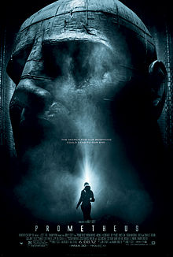
Coming to life itself the critical question is how did it start – what is the origin of life? How did self- replicating DNA get going? In the 2012 Ridley Scott film Prometheus, there is an opening scene of an alien pouring DNA into a fast flowing river seeding earth with life. This scene picks up on the proposal made by the famous chemist and equally famous atheist Francis Crick, who was one of the co-discoverers of DNA. Faced the overwhelming unlikelihood of enzymes combining to form self-replicating DNA he proposed the idea that DNA was seeded on earth by aliens. An idea called Panspemia.
The reason Francis Crick, had to propose such an idea is that he was honestly facing up to the reality that blind forces of physics would not create DNA. Physicists Fred Hoyle and Chandra Wickamasighe, said:
“The trouble is that there are about two thousand enzymes, and the chance of obtaining them all in a random trial is only one part in (10²⁰)²⁰⁰⁰ = 10^{40,000}, an outrageously small probability that could not be faced even if the whole universe consisted of organic soup.”
The Christian view is that in a way Francis Crick is correct. It took something outside nature to get life kick started - to get self-replicating DNA going. That thing outside nature was not an alien, however, but it was the person revealed in scripture as God.
Having created a universe with the precisely calibrated conditions we observe in it, then having started life we come to evolution. Evolution is the theory of how life, once started, produces people, the apex of creation.
Atheists reason that because evolutionary theory references a concept called chance that God can be removed from the picture at least at this point. But “chance” is to evolution what “free will” is to history. Just as it is true that we all have free will nonetheless God causes the events in history to occur. The best example of this is Christ’s passion. Each actor in the drama of betrayal, trial, torture and crucifixion acted with complete free will yet those events also evidenced God’s sovereign will at work causing those things to happen. The analogy applies equally to evolutionary theory and the process leading to the creation of the first humans.
Under an evolutionary theory one still arrives by definition, eventually at the first of a species. The first of the new species like the new species itself need a name and the Bible gives them names – Adam and Eve. Adam in Hebrew also means mankind. The Bible names the individuals and the race in a wonderful play on words.
In conclusion the overwrought tension between the secular mind and the theistic, might be reduced if evolutionary theories were taught more rigorously. Evolution is often simply assumed. We are all used to evolution as story, as told by David Attenborough in television series like Planet Earth.
The reality is that evolution is not a monolithic topic. There are competing views held by scholars. There have been different theories advocated by different thinkers; there are different camps, ferment and disagreement amongst scholars over the mechanisms that might be involved, criticism and counter criticism, just as there are in other areas of science and inquiry.
Wouldn’t it be wonderful if secular started to mean “neutral” which is of course what the word is meant to mean.

Genesis 30:25 and following.
Robert J. Spitzer New Proofs for the existence of God. (Wm. B Eerdmans Publishing Company, Grand Rapids, Michigan, 2010) page 54 to 56.
Ibid page 57.
Ibid page 58.
Ibid 59. A. First photo is by Rob Sheridian, Flicker Common’s licence. Photo in turn from NASA common’s licence material. B. Second photo Prometheus, film promotion poster from Wikipedia site.
“Do our genes revel the hand of God?” www.telegraph.co.uk/connected/main.jhtml/?xml=/connected/2003/03/19/ecfgod19.xml, 15 July 2003.
Fred Hoyle and Chandra Wickramasighe, Evolution from Space (New York; Simon and Schuster, 1981), p 24.

